HTML id Attribute and HTML class Attribute

📘 Definition
# Source: AI Source: Provided by: [Data Path: Persons Table -> ID Column: 1, Name_En Column: Motasem Essam] -> From: [ChatGPT] on [5/6/2026]
Both class and id are HTML attributes used to identify and target elements for:
- 🎨 CSS styling
- ⚡ JavaScript interaction
- 🧩 Organization

🆔 HTML id Attribute

📖 Description
# Source: AI Source: Provided by: [Data Path: Persons Table -> ID Column: 1, Name_En Column: Motasem Essam] -> From: [ChatGPT] on [5/6/2026]
The id attribute gives an element a unique name.
👉 One id should be used for only one element on the page.

💻 Example
# Source: AI Source: Provided by: [Data Path: Persons Table -> ID Column: 1, Name_En Column: Motasem Essam] -> From: [ChatGPT] on [5/6/2026]
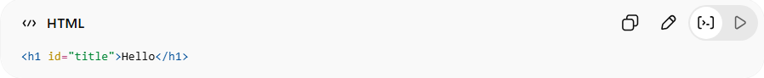
<h1 id="title">Hello</h1>

🎨 CSS Example
# Source: AI Source: Provided by: [Data Path: Persons Table -> ID Column: 1, Name_En Column: Motasem Essam] -> From: [ChatGPT] on [5/6/2026]
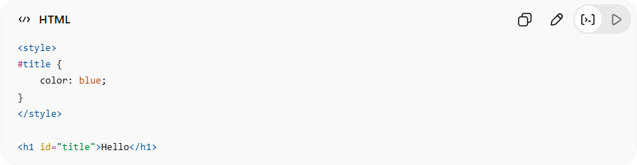
<style>
#title {
color: blue;
}
</style>
<h1 id="title">Hello</h1>
👉 # is used for IDs in CSS

⚡ JavaScript Example
# Source: AI Source: Provided by: [Data Path: Persons Table -> ID Column: 1, Name_En Column: Motasem Essam] -> From: [ChatGPT] on [5/6/2026]
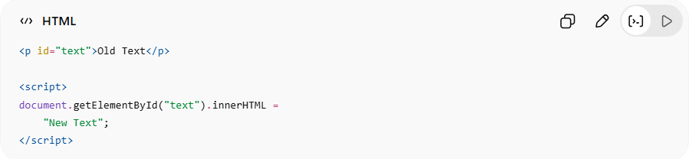
<p id="text">Old Text</p>
<script>
document.getElementById("text").innerHTML =
"New Text";
</script>
👉 JavaScript finds the element using its unique ID

🏷️ HTML class Attribute

📖 Description
# Source: AI Source: Provided by: [Data Path: Persons Table -> ID Column: 1, Name_En Column: Motasem Essam] -> From: [ChatGPT] on [5/6/2026]
The class attribute groups multiple elements under the same name.
👉 Many elements can share the same class.

💻 Example
# Source: AI Source: Provided by: [Data Path: Persons Table -> ID Column: 1, Name_En Column: Motasem Essam] -> From: [ChatGPT] on [5/6/2026]
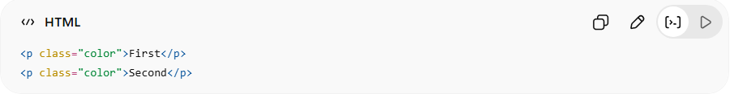
<p class="color">First</p>
<p class="color">Second</p>

🎨 CSS Example
# Source: AI Source: Provided by: [Data Path: Persons Table -> ID Column: 1, Name_En Column: Motasem Essam] -> From: [ChatGPT] on [5/6/2026]
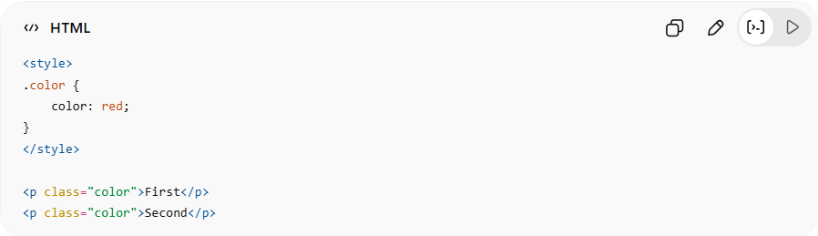
<style>
.color {
color: red;
}
</style>
<p class="color">First</p>
<p class="color">Second</p>
👉 . is used for classes in CSS

⚡ JavaScript Example
# Source: AI Source: Provided by: [Data Path: Persons Table -> ID Column: 1, Name_En Column: Motasem Essam] -> From: [ChatGPT] on [5/6/2026]
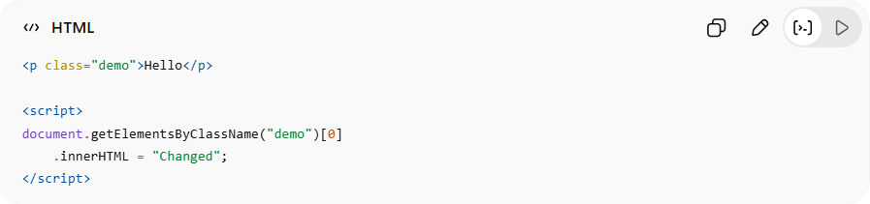
<p class="demo">Hello</p>
<script>
document.getElementsByClassName("demo")[0]
.innerHTML = "Changed";
</script>

⚖️ Difference Between id and class
# Source: AI Source: Provided by: [Data Path: Persons Table -> ID Column: 1, Name_En Column: Motasem Essam] -> From: [ChatGPT] on [5/6/2026]
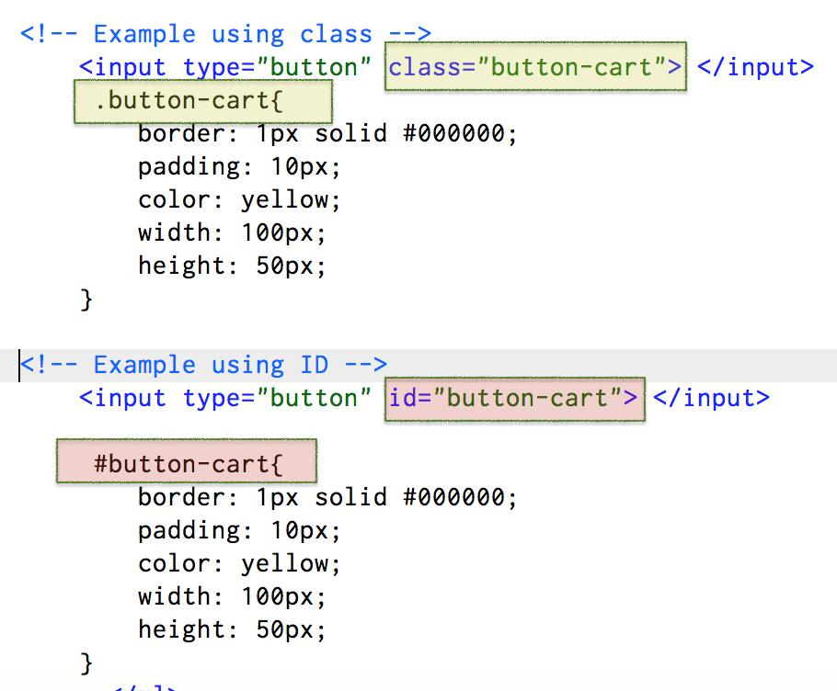
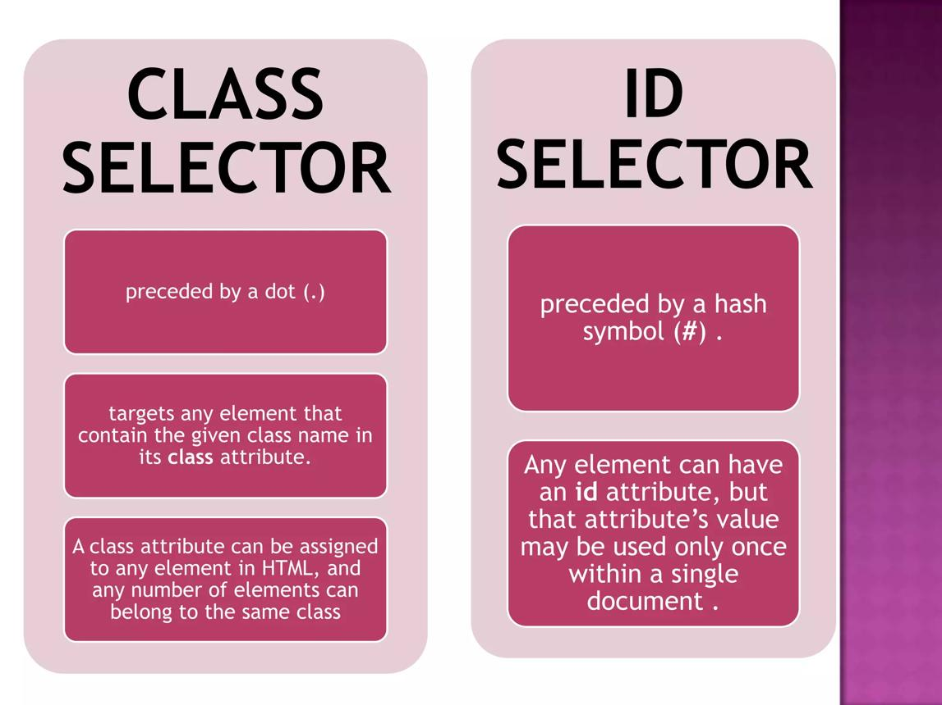
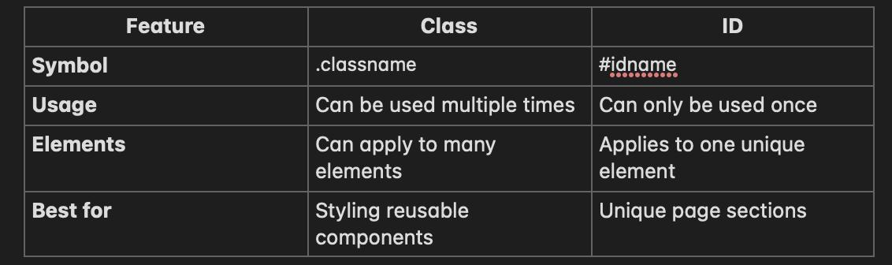
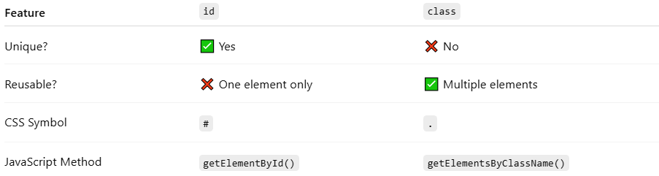
Feature | id | class
Unique? | ✅ Yes | ❌ No
Reusable? | ❌ One element only | ✅ Multiple elements
CSS Symbol | # | .
JavaScript Method | getElementById() | getElementsByClassName()

🚫 Common Mistakes
# Source: AI Source: Provided by: [Data Path: Persons Table -> ID Column: 1, Name_En Column: Motasem Essam] -> From: [ChatGPT] on [5/6/2026]
❌ Repeating IDs
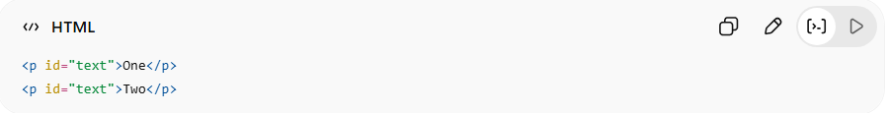
<p id="text">One</p>
<p id="text">Two</p>
👉 Invalid because IDs should be unique
✅ Correct
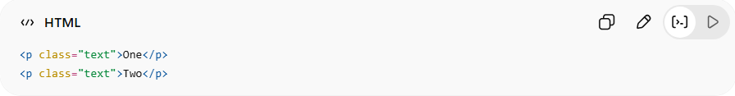
<p class="text">One</p>
<p class="text">Two</p>

🚀 Best Practice
# Source: AI Source: Provided by: [Data Path: Persons Table -> ID Column: 1, Name_En Column: Motasem Essam] -> From: [ChatGPT] on [5/6/2026]
- 🆔 Use id for unique elements
- 🏷️ Use class for reusable styles/groups

🚀 In short:
# Source: AI Source: Provided by: [Data Path: Persons Table -> ID Column: 1, Name_En Column: Motasem Essam] -> From: [ChatGPT] on [5/6/2026]
- id = unique identifier for one element
- class = reusable name shared by multiple elements

